**CENWP-ODJ8/25/2023**

**MEMORANDUM FOR THE RECORD**

**SUBJECT: *23JDA35 Chinook Morts in Gatewell 1C***

On Friday 25 August 2023, at approximately 0900, JDA fisheries personnel found 3 Chinook subyearling morts in gatewell 1C (see figure 1). They were removed from the gatewell, scanned for PIT tags (no tags), and returned to the river. The morts varied in decomposition levels and injuries (see “Marks and Injuries” below). This is the 5th incident within gatewell 1C over the past 17-days (see 23JDA31 – 23JDA34). As this has happened on the project’s weekend, no further investigation is possible at this time. Operations was contacted and switched MU-1 to a “last-on first-off” operation that will keep unit prioritization in line with FPP guidelines. On Monday 28 August, crews will begin to further investigate the underlying issue before returning MU-1 to normal operation.

Measures Already Taken

1. An STS inspection was performed on Thursday 10 August, 2-days after the 1st incident. No visible damage was observed.
2. An ROV was used to inspect the 1C orifice on Tuesday 22 August with no visible obstructions (see figure 2).
3. On Tuesday 22 August a backflush of the JBS was performed to ensure there were no obstructions on the backend of the orifice (unlikely scenario).
4. The 1C orifice limit switch was replaced on Thursday 24 August.

Additional Information

1. Total morts in 1C since 1st observation: 22-subyearling Chinook, 1 minijack Chinook, and 1-adult sockeye.
2. There are 10’s of thousands of juvenile shad using the same gatewell that appear fine.
3. Those same shad may be congesting the gatewell.
4. With the low spill volumes, the majority of fish would be getting pulled towards 1C.
5. The JDA forebay water temperature is 72.1°F (at the time of preparing this memo).
6. The SMF was running at 100% collection on Thursday 24 August with no unusual marks or mortalities. Additionally, there were only 6-fish over 6-hours of collection.
7. Throughout this issue, the age of decomposition has varied from fresh to several days old, despite daily inspections of the gatewell.
8. At the time of this memo’s preparation, unit demands are low making the need for running MU-1 low.

**Update 8/28/23**

* On the morning of Monday 28 August, the JDA mechanical crew performed a STS inspection on gatewell 1C. They found the orifice wasn’t opening despite indications that it was. The hardware attaching the actuator to the orifice broke off.
* The JDA crew dipped the gatewell 6-times before lowering a bulkhead in 1C. There were 10’s of thousands of juvenile shad, 2-adult steelhead, and 6-subyearlings netted out of the gatewell. They were all released in good condition.
* At approximately 1630 on Monday 28 August, the orifice repair had been completed, the bulkhead was removed, and an orifice inspection was performed to ensure the repairs were completed.

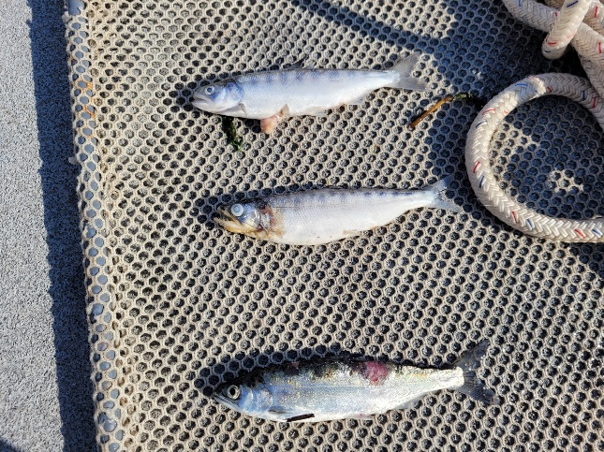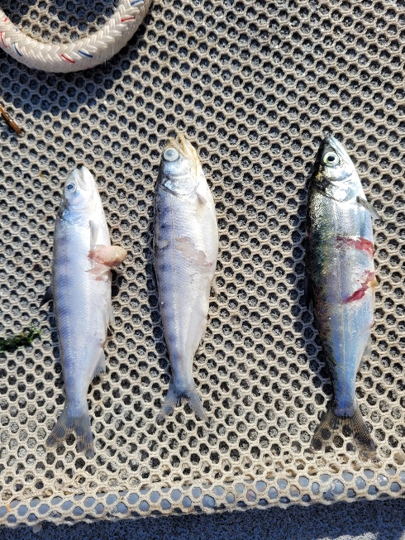

Figure 1: Mortalities found in gatewell 1C on 8/25/23

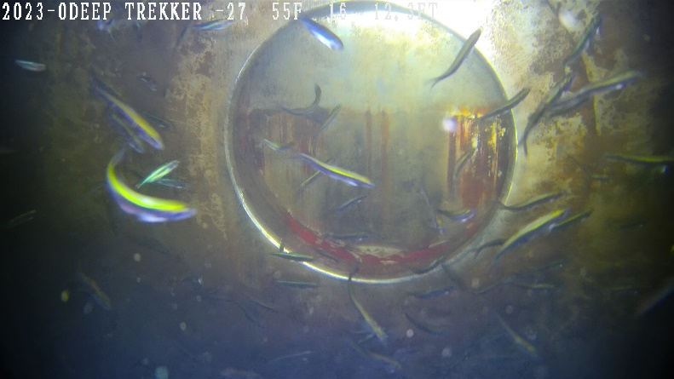

Figure 2: ROV image from orifice inspection on 8/22/23

1. Species – Chinook subyearling
2. Origin – clipped (although 2-appear to have partially clipped adipose fins)
3. Length – ~12cm
4. Marks and tags – None
5. Marks and Injuries found on carcass – Lower mort had wounds resembling a predator strike along with a gash on the mid-dorsal section, the upper has a puncture wound on the ventral side, the middle mort is more decayed and appears to have a gash on the left-anterior side. All had some degree of descaling.
6. Cause and Time of Death – Unknown
7. Future and Preventative Measures – MU-1 has been taken offline as a last-on first-off unit until crews are able to do a more thorough inspection on Monday 28 August. They will likely begin with another STS inspection, and if there are no apparent issues, they may need to dewater the unit for a better look.

Sincerely,

JDA Project Fisheries